Censorship Hot Topics

As a group, come up with as many arguments as you can
for and against one of the following statements:

(1) Books with swearing and sexuality should not be taught in schools.

(2) It should be illegal for any person under the age of sixteen to purchase or play violent video games like ‘Grand Theft Auto.’

(3) Songs with profane lyrics should not be censored on the radio.

(4) People who watch movies about drugs and crime are more likely to end up as addicts and criminals.

(5) Images of scantily clad pop stars are damaging to young women and should not be included in magazines or on television.

(6) Censorship is the first step towards the creation of an oppressive, fascist society.

(7) We should not read older books that contain racist attitudes, even if they are considered classics.

(8) No book, movie, song or image should be deliberately offensive to any minority.

Instructions
Read the two excerpts from Fahrenheit 451 on this page and on the back of this page. Each group member should take notes. As a group, list as many events from the plot of The Hearth and the Salamander that change Montag from the man described in the first quote to the man he becomes at the end of that part of the book (described in the second quote). Each group member should take notes. Use the questions below to help guide your discussion.

At the end of the discussion period your group will report on the events that you have identified.

Questions

When you read the first excerpt, do you think that Montag is a truly happy man?

Why is Montag not so happy by the end of The Hearth and the Salamander; the part of the book that the second excerpt comes from?

How does Montag feel about Clarisse?

What is his reaction when Clarisse disappears?

What can we infer about the society of Fahrenheit 451 from the fact that the paramedics that come to treat Mildred do the same thing eight or nine times a night?

Do you get the feeling that Montag approves of his wife’s television habits?

What does Montag talk about with the old woman before she lights the match that ignites the kerosene?
Excerpt #1

“It was a pleasure to burn.

It was a special pleasure to see things eaten, to see things blackened and changed. With the brass nozzle in his fists, with this great python spitting its venomous kerosene upon the world, the blood pounded in his head, and his hands were the hands of some amazing conductor playing all the symphonies of blazing and burning to bring down the tatters and charcoal ruins of history. With his symbolic helmet number 451 on his stolid head, and his eyes all orange flame with the thought of what came next, he flicked the igniter and the house jumped up in a gorging fire that burned the evening sky red and yellow and black. He strode in a swarm of fireflies. He wanted above all, like the old joke, to shove a marshmallow on a stick in the furnace, while the flapping pigeon-winged books died on the porch and lawn of the house. While the books went up in sparkling whirls and blew away on a wind turned dark with burning.

Montag grinned the fierce grin of all men singed and driven back by flame.

He knew that when he returned to the firehouse, he might wink at himself, a minstrel man, burnt-corked, in the mirror. Later, going to sleep, he would feel the fiery smile still gripped by his face muscles, in the dark. It never went away, that smile, it never ever went away, as long as he remembered.”

Excerpt #2

"It's not just the woman that died," said Montag. "Last night I thought about all the kerosene I've used in the past ten years. And I thought about books. And for the first time I realized that a man was behind each one of the books. A man had to think them up. A man had to take a long time to put them down on paper. And I'd never even thought that thought before." He got out of bed.

"It took some man a lifetime maybe to put some of his thoughts down, looking around at the world and life, and then I come along in two minutes and, boom! It’s all over."

"Let me alone," said Mildred. "I didn't do anything."

"Let you alone! That's all very well, but how can I leave myself alone? We need not to be let alone. We need to be really bothered once in a while. How long is it since you were really bothered? About something important, about something real?"
Unit Title: Fahrenheit 451 Date: _____________________
Part One: The Hearth and the Salamander

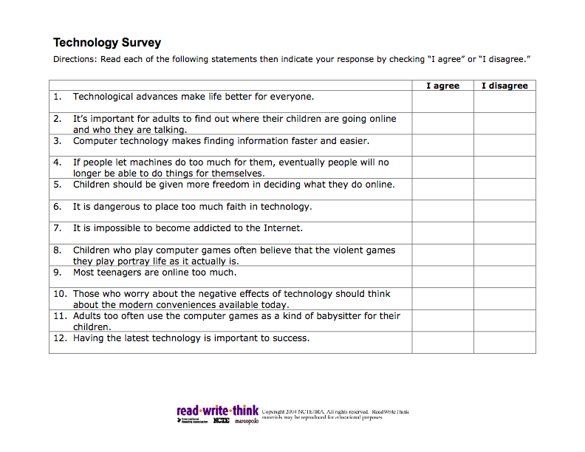

LITERARY DEVICES

In your groups, read the following and decide what literary device is being employed (symbolism, metaphor, simile or foreshadowing).

- I remember the newspaper dying like huge moths.

- I lived alone for so many years, throwing images on walls with my imagination.

- The Phoenix.

- Job of firemen in Montag’s society.

- He wore his happiness like a mask and the girl had run across the lawn with the mask.

- Her face, turned to him now, was fragile milk crystal with a soft and constant light in it.

- He was as happy as a lark.

- The Salamander.

- Beatty tells Montag that he merely has to burn his problems.
fa

